# Arduino in/out

Lickdetector and reward system for DPX using Arduino

### Get an Arduino Uno R3

This $25 device can be bought online:

<http://arduino.cc/en/main/arduinoBoardUno>

I just happen to use this one because it’s basic, but if it’s not available when you read this in the future, any Arduino device will probaly suffice for this very basic IO task.

### Install the Arduino driver and software

<http://arduino.cc/en/Main/Software>

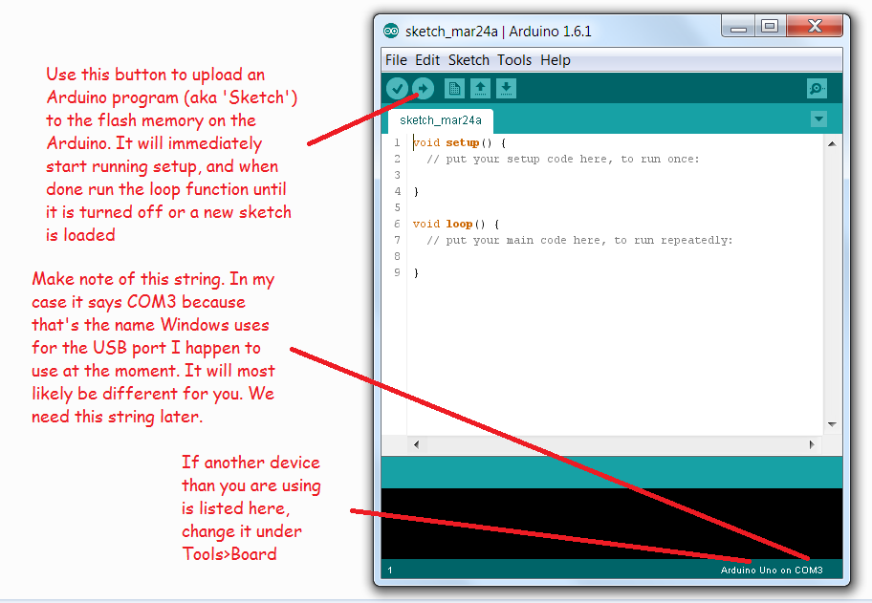

### Install Aduino support for Matlab

This software provides matlab functions to interact with the Arduino

<http://nl.mathworks.com/hardware-support/arduino-matlab.html>

### Update DPX, per 2015-03-24 I’ve added Arduino functionality

<http://tinyurl.com/dpxlink>

I’ve added these files:

|  |  |
| --- | --- |
| Arduino DPX.docx | This document. |
| dpxPluginArduino.m | Start and stop the serial-link connection between Matlab and the Arduino |
| dpxStimArduinoPulse.m | Pulse output from the Arduino (reward) |
| dpxRespArduinoPulse.m | Pulse input (one or multiple lick-detectors) |
| dpxExampleExperimentArduinoInOut.m | Example file for using two digital inputs on PIN 2 and 4 of the Arduino and a single digital output on PIN 13 |
| dpxArduino24in13out.ino | This file is ‘hidden’ in .\DPX\dpxPlugins\@dpxPluginArduino\private\dpxArduino24in13out  Upload this file to the flash memory of the Arduino as described earlier. It is hidden so that it doesn’t show up on the Matlab path, which is good because Matlab can’t read this file anyway. |

I recommend you take a close look at dpxExampleExperimentArduinoInOut.m and read the comments in dpxArduino24in13out.ino. If you have any question, contact me on [j.duijnhouwer@gmail.com](mailto:j.duijnhouwer@gmail.com)

Best,

Jacob